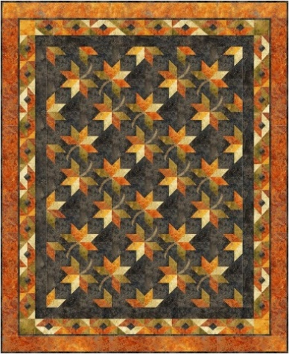
24th Annual Frozen Fabric Frolic Quilt Retreat
Missouri Valley Quilters, Bismarck-Mandan

Crystal Springs Bible Camp, 4848 36th St SE, Medina, ND
February 16-18, 2024

Retreat begins 10:00 AM Friday, Feb. 16 and ends at 5:00 PM Sunday, Feb. 18
$175 Registration Fee. $75 is required with application.
Cancellation before Feb. 6, 2024 will receive a refund minus a $10 fee.

“Hunter’s Canopy”

Meals
Lunch & Supper Friday, Brunch & Supper Saturday, Brunch Sunday.

Lodging
Dormitory style—12 large rooms with up to 6 twin sized beds in each large room.
Showers and bathrooms are located in the dormitory building.
You will supply your own twin sized bedding, pillow, towels and toiletries.

Participate in “Hunter’s Canopy” class—Variation of Hunter’s Star block to make 70” x 85” quilt
Or BYOP--bring your own projects.
Information at missourivalleyquilters.com

Members of Missouri Valley Quilters may send in their registration on November 1, 2023
Open registration will begin December 1, 2023 for non-members of MVQ.
Registration will be limited to 40 participants.

Detailed supply lists will be mailed prior to the retreat.
__________________________________________________________________________________________________

Please mail to: Barb Headrick 122 East Arikara Ave. Bismarck ND 58501

Name _________________________________________________ Phone __________________

Address ________________________________________________________________________
State _______ Zip Code __________ E-mail___________________________________________
Amt. Enclosed $175 ________ (Paid in Full) $75 ________ ($100 due at Registration)
This includes a $10 nonrefundable registration fee. Make checks payable to Missouri Valley Quilters.

Please indicate Class Preference
“Hunter’s Canopy” ________ Sew Your Own Project _________

Please contact Barb Headrick at 425-2171 if you have any food allergies.

If you have any questions, please call Barb Headrick at 425-2171 or email bhquilt@midco.net

